Q1) Implement a CUDA program to determine the number of CUDA-capable devices in the system. For each device, examine the following device properties:
- a) Device name
- b) Number of Streaming Multiprocessors
- c) Maximum number of threads per block
- d) Maximum thread dimensions (x, y, z)
- e) Maximum grid dimensions (x, y, z)
- f) Device clock frequency
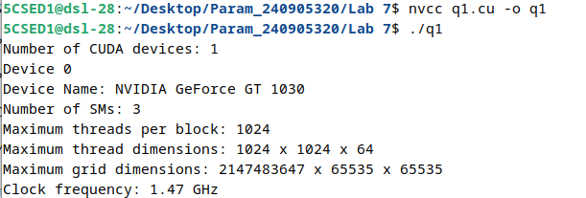

Q2) Given two vectors of length N, implement a CUDA program that launches two kernels to perform the following tasks:
- a) Add two vectors (kernel execution configuration: block size as N)
- b) Compute the dot product of two vectors (kernel execution configuration: N threads)
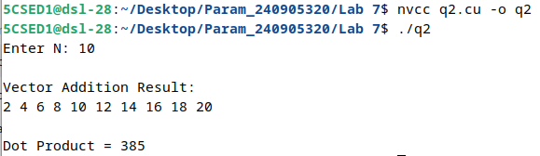
Q3) Implement a CUDA program to compute the Euclidean distance between two randomly initialized vectors A and B, each of length N. Keep the number of threads per block fixed at 256 and dynamically determine the number of blocks required to process all N elements.
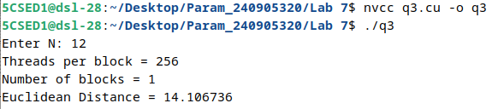

Q4) Implement a CUDA program to process a 1D array containing angles in radians and generate the sine of the angles in the output array. Use the appropriate CUDA function.
